# Introduction

This task is the improved version base on the previous lab03

SVM model is implemented with a few plot twisted on train/predict/evaluate function to fit the format while keeping the dataset the same on lab03

# The columns selected for prediction

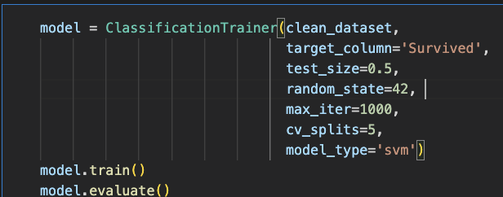

Target Column is 'Survived'

# The training and testing split

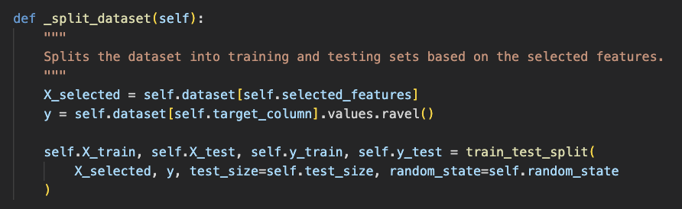

Splitting dataset is easy to adjust as it is the implemented in ClassificationTrainer class as it shows in the above section

# The SVM model building

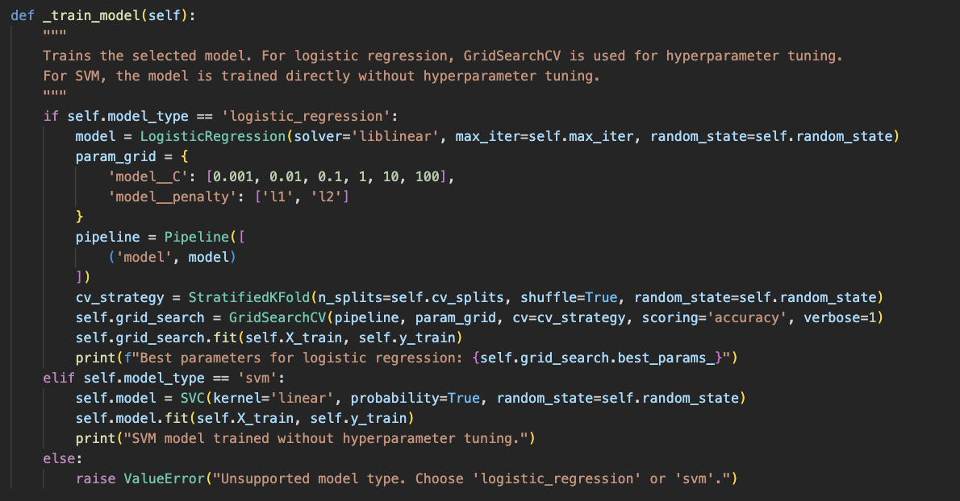

I have implemented model_type = 'svm' (this is an improved version base on lab03)

# The Accuracy

